**ASSIGNMENT 3**

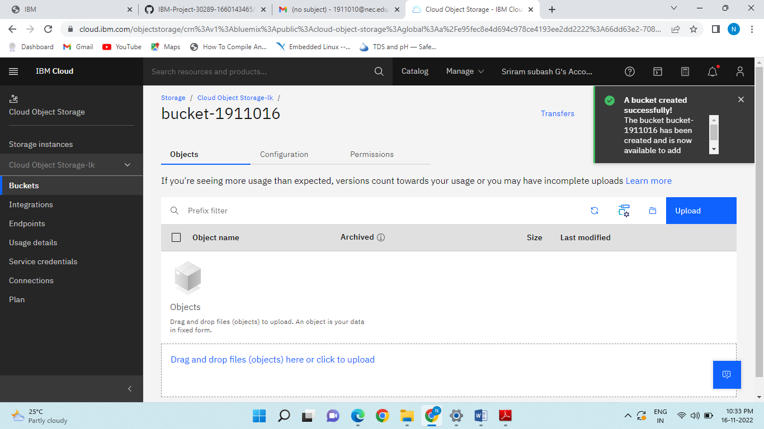

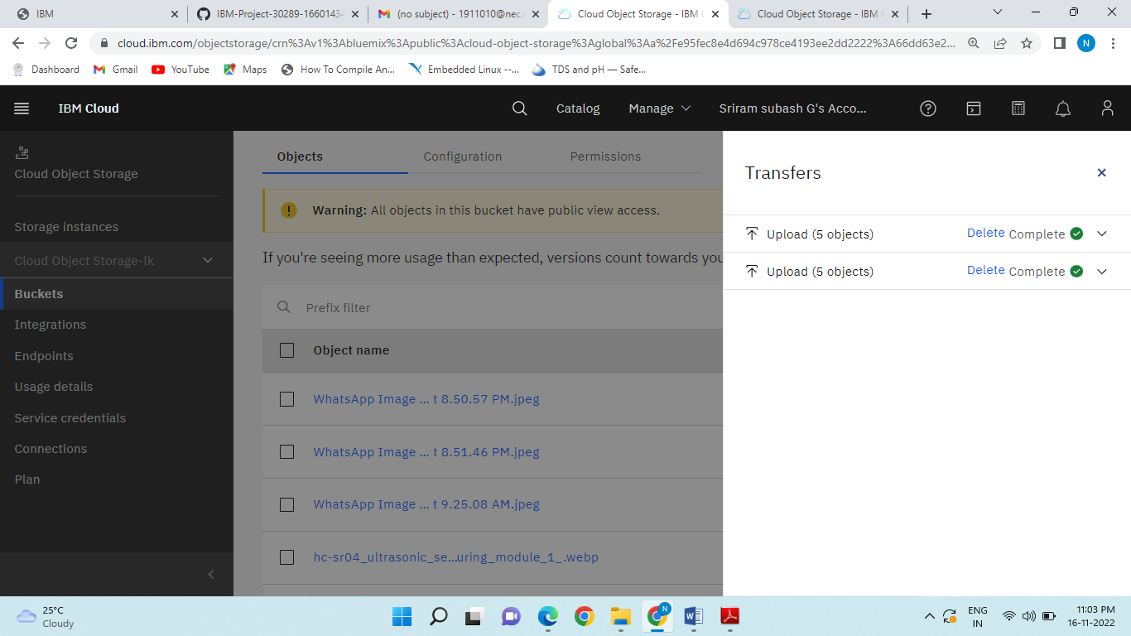

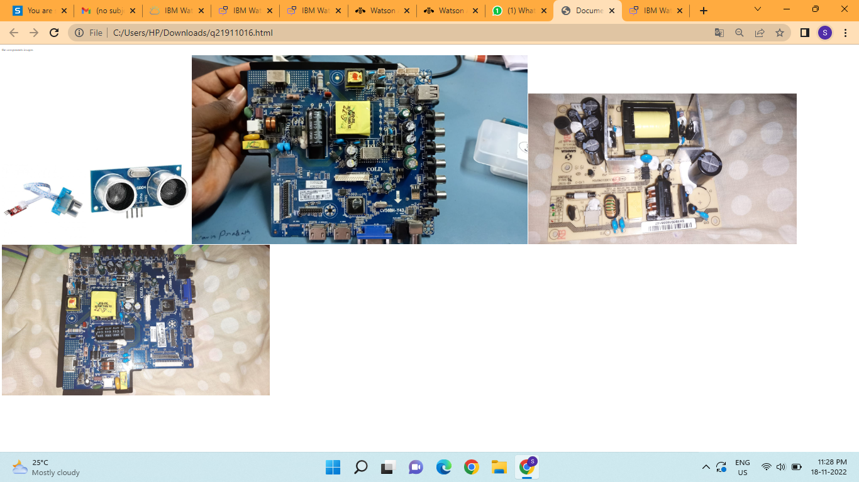

[**https://au-syd.assistant.watson.cloud.ibm.com/crn%3Av1%3Abluemix%3Apublic%3Aconversation%3Aau-syd%3Aa%2Fe95fec8e4d694c978ce4193ee2dd2222%3A1a50fecc-17b2-4a91-9942-dd9de007bd38%3A%3A/assistants/3d6dab34-e0bf-4e46-ae6b-2454c3cfb8fe/actions/actions/custom/edit/action_14173**](https://au-syd.assistant.watson.cloud.ibm.com/crn%3Av1%3Abluemix%3Apublic%3Aconversation%3Aau-syd%3Aa%2Fe95fec8e4d694c978ce4193ee2dd2222%3A1a50fecc-17b2-4a91-9942-dd9de007bd38%3A%3A/assistants/3d6dab34-e0bf-4e46-ae6b-2454c3cfb8fe/actions/actions/custom/edit/action_14173)

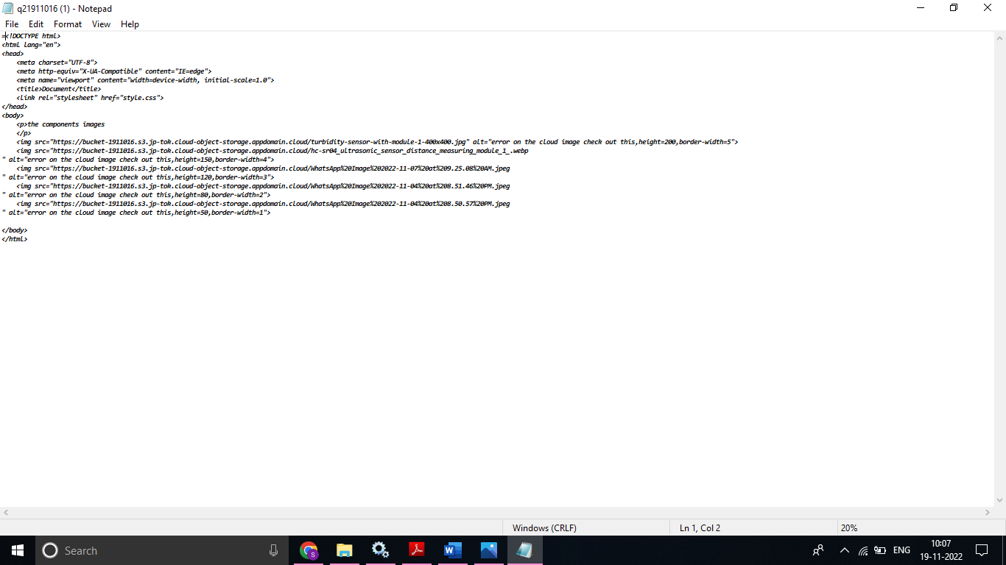

**Submitted by**

**G.Sriram Subash**

**1911016**